Department of Mathematics
Name of the Programme : M.A./M.Sc. Mathematics
Credit Template
Semester I
Paper
code
Paper Title
Type of Paper
(Theory,
Practical Project,
Seminar)

Theory
Theory
Theory
Theory
Theory
Seminar
Contact Hours
Per
Sem
60
60
60
60
60
30
Per
week
4
4
4
4
4
2
4
4
4
4
4
2
22
Credits
Max.
Marks
Min.
Marks
MAT 121
MAT 122
MAT 123
MAT 124
MAT 125
MAT 126
Advanced Abstract
Algebra
Real Analysis
Advanced Differential
Equations
Differential Geometry- I
Dynamics of a Rigid Body
Seminar
100
100
100
100
100
36
36
36
36
36
Total Credits for Semester I
Semester II
Paper
code
Paper Title
Type of Paper
(Theory,
Practical Project,
Seminar)

Theory
Theory
Theory
Theory
Theory
Seminar
Contact Hours
Per
Sem
60
60
60
60
60
30
Per
week
4
4
4
4
4
2
4
4
4
4
4
2
22
Credits
Max.
Marks
Min.
Marks
MAT 221
MAT 222
MAT 223
MAT 224
MAT 225
MAT 226
Linear Algebra
Topology
Special Functions
Differential Geometry-II
Hydrodynamics
Seminar
100
100
100
100
100
100
36
36
36
36
36
36
Total Credits for Semester II
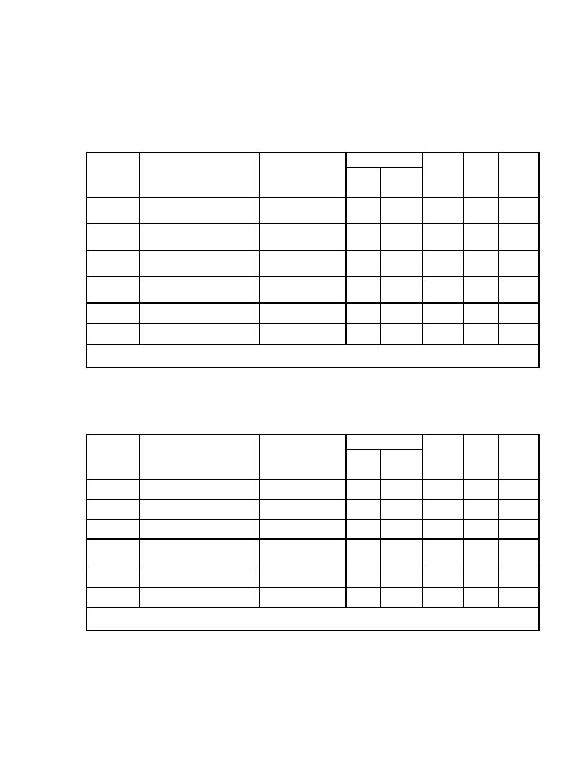
Paper
code
Paper Title
Type of Paper
(Theory,
Practical Project,
Seminar)
Theory
Theory
Theory
Theory
Theory
Seminar
Contact Hours
Per
Sem
Per
week
Credits
Max.
Marks
Min.
Marks
Group A * Applied Mathematics
MAT 321A
MAT 322A
MAT 323A
MAT 324
MAT 325
MAT 326
Group B*
MAT 321B
MAT 322B
MAT 323B
MAT 324
MAT 325
Numerical methods by C,
C++/ Matlab
Mathematical
Programming
Integral transforms and
Integral equations
Functional Analysis-I
Fluid Dynamics-I
Seminar
Pure Mathematics
Ring theory
General Topology
Advanced Complex
Analysis
Functional Analysis-I
Fluid Dynamics-I
Theory
Theory
Theory
Theory
Theory
Seminar
60
60
60
60
60
30
4
4
4
4
4
2
4
4
4
4
4
2
22
100
100
100
100
100
100
36
36
36
36
36
36
60
60
60
60
60
30
4
4
4
4
4
2
4
4
4
4
4
2
100
100
100
100
100
100
36
36
36
36
36
36
MAT 326Seminar
Total Credits for Semester III
Paper
code
Paper Title
Type of Paper
(Theory,
Practical Project,
Seminar)
Theory
Theory
Theory
Theory
Theory
Seminar
Theory
Theory
Theory
Theory
Theory
Seminar
Contact Hours
Per
Sem
Per
week
Credits
Max.
Marks
Min.
Marks
Group A*
MAT 421A
MAT 422A
MAT 423A
MAT 424
MAT 425
MAT 426
Group B *
MAT 421B
MAT 422B
MAT 423B
MAT 424
MAT 425
MAT 426
Applied Mathematics
Mathematical Modelling
and Simulation
MHD/Theory of Statistics
Operations Research
Functional Analysis-II
Fluid Dynamics-II
Dissertation
Pure Mathematics
Advance Ring Theory
Analytic Number Theory
Approximation Theory
Functional Analysis-II
Fluid Dynamics-II
Dissertation
60
60
60
60
60
60
60
60
60
60
60
60
4
4
4
4
4
4
4
4
4
4
4
4
4
4
4
4
4
4
4
4
4
4
4
4
24
90
100
100
100
100
100
100
100
100
100
100
100
100
36
36
36
36
36
36
36
36
36
36
36
36
Total Credits for Semester IV
Total Credits (Sem. I to Sem IV)
* Out of the two groups viz. A and B, a student is required to opt. for the Papers from any one
group (i.e. A or B) during Semesters III and IV. The paper opted for in one group in Semester III
must correspond to the same paper in Semester IV (eg. MAT 321A & MAT 421A).
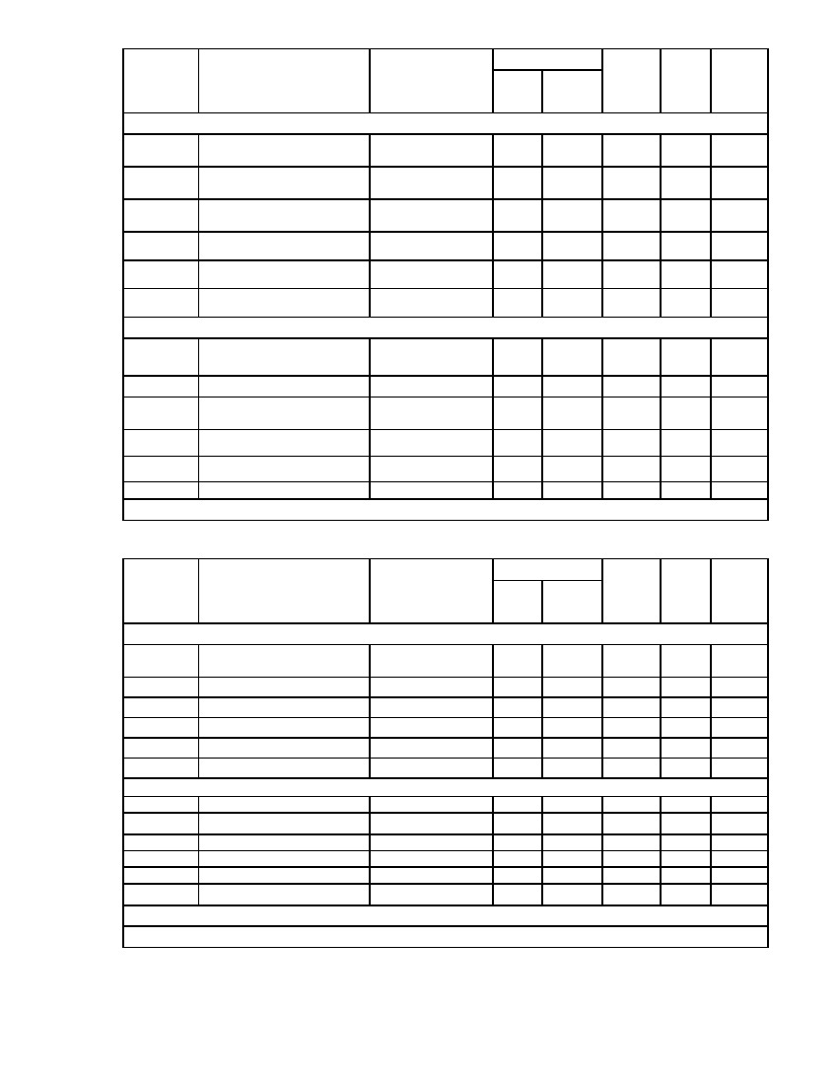
Semester III

Semester IV

