One-pot 1,3-Dipolar Cycloaddition of Isoquinolinium Ylide with Dimethyl Acetylenedicarboxylate in Water.
Yashasvi Yadav, R.K.Bansal*
The IIS University
Yashasviyadav22684@iisuniv.ac.in
1,3-dipolar cycloaddotion reaction of pyridinium and other related ylides constitutes an important synthetic strategy for preparing indolizine derivatives. A survey of the literature revealed that this reaction has been so far accomplished in multiple steps using halogenated organic solvents. We have for the first time developed a strategy in which the whole process including generation of the ylide and its subsequent 1,3-dipolar cycloaddition with dimethyl acetylenedicarboxylate has been accomplished in one-pot using water as the solvent.
Scheme 1. Formation of 2-phenacylisoquinolinium bromide.
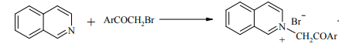
Scheme 2. Formation of isoquinolinium phenacylide.
Scheme 3. 1,3-Dipolar cycloaddition of isoquinolinium phenacylide with DMAD.

The product was identified on the basis of IR, ¹H NMR, and ¹³C NMR spectroscopy.

